Gabon

## Political Stability Estimate Data

The data set shows the political stability estimate of the country each year.

## # A tibble: 19 x 5  
## country iso3c date stability stabilityCategory4   
## <chr> <chr> <dbl> <dbl> <chr>   
## 1 Gabon GAB 1996 0.124 moderately stable   
## 2 Gabon GAB 1998 0.324 moderately stable   
## 3 Gabon GAB 2000 0.637 moderately stable   
## 4 Gabon GAB 2002 0.406 moderately stable   
## 5 Gabon GAB 2003 0.299 moderately stable   
## 6 Gabon GAB 2004 0.408 moderately stable   
## 7 Gabon GAB 2005 0.326 moderately stable   
## 8 Gabon GAB 2006 0.220 moderately stable   
## 9 Gabon GAB 2007 0.303 moderately stable   
## 10 Gabon GAB 2008 0.264 moderately stable   
## 11 Gabon GAB 2009 0.142 moderately stable   
## 12 Gabon GAB 2010 0.299 moderately stable   
## 13 Gabon GAB 2011 0.385 moderately stable   
## 14 Gabon GAB 2012 0.293 moderately stable   
## 15 Gabon GAB 2013 0.330 moderately stable   
## 16 Gabon GAB 2014 0.150 moderately stable   
## 17 Gabon GAB 2015 0.0212 moderately stable   
## 18 Gabon GAB 2016 -0.105 moderately unstable  
## 19 Gabon GAB 2017 -0.0892 moderately unstable

## Political Stability Estimate Plot

The plot shows the trends of stabilization and destabilization for the each country.

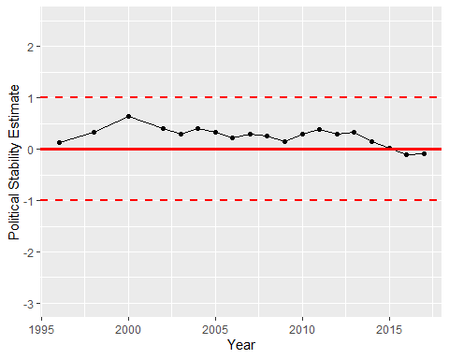

Political Stability Trend